Blade Archie and David Huber

Fall 2022

|  |
| --- |
|  |
| ITEC 3200 |
|  |
| Airport Data Collection |

ITEC 3200

Executive Summary

**Objective**

This database was designed to assist airport managers and executives to help track and upkeep information of employees, airports, planes, airlines, and flights

**Goals**

Our goal with this database is to supply an easy and organized way of storing and retrieving data in an airport environment, in doing so we will create queries that relate to deliverables an airport would need about airlines, airports, employees, and planes for day-to-day tasks and projected expansion.

**Solution**

The solution for such a goal would be the creation of database tables and the relationships between those tables. Our tables consist of Airline, Airport, Employee, Planes, and Airline_has_Planes as to help tie the airlines to their planes that go to different airports. These tables serve as the main entities of the database and contain a relationship between one another represented by a line that represents its own type of relationship. Using the tables provided we can create queries and retrieve data for the information necessary for management in this facet of management.

This project will be implemented in using SQL in MySQL Workbench.

**Benefits to Users**

With this database users will find that it is a valuable tool in providing and retrieving information, in an expedited and convenient form. It will assist in the consolidation of tasks, operations and help to retrieve information for management to track.

**Project Outline**

The project will contain the following major components:

* Entity-Relationship Diagram
* Table Implementation
* Queries

ITEC 3200

Entity-Relationship Diagram

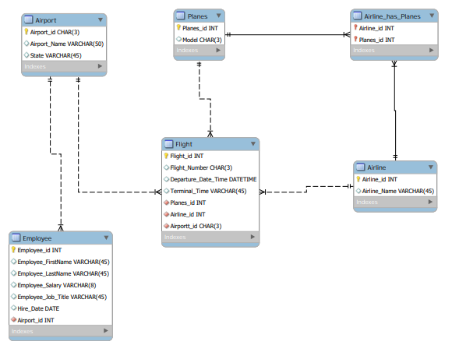

ITEC 3200

Table Implementation

Airline: Airline_has_planes:

Airport:

Employee:

ITEC 3200

Table Implementation

Planes:

ITEC 3200

Query Implementation

### Query 1

* Query shows Employees with an “H” starting name and are a Guard

### Query 2

* Query shows Employees with a hire date in the 90’s

### Query 3

* Query shows the first alphabetical half of airport codes and their states

### Query 4

* Query shows the name of the airline of the flights leaving ATL

### Query 5

* Query will compute the employee's salary before and after taxes. It will be rounded to a whole number.

### Query 6

* Query will contain the plane’s ID as well as the total flights of that plane.

### Query 7

* Query will find the ID of the airport where Employee’s first name are Bob or Sam. Then, the second query will get their ID and Job Title. Query 7 is a Nested Query.